Using the Relco SC480 calibration lamp

Jerry Foote 07/08/2019

The Relco calibration lamp is a useful source of calibration lines having both Neon and Argon gas. This lamp is used in Shelyak’s Alpy and Lisa spectrographs calibration units.

We have been powering these lamps from a small high voltage power supply out of China.

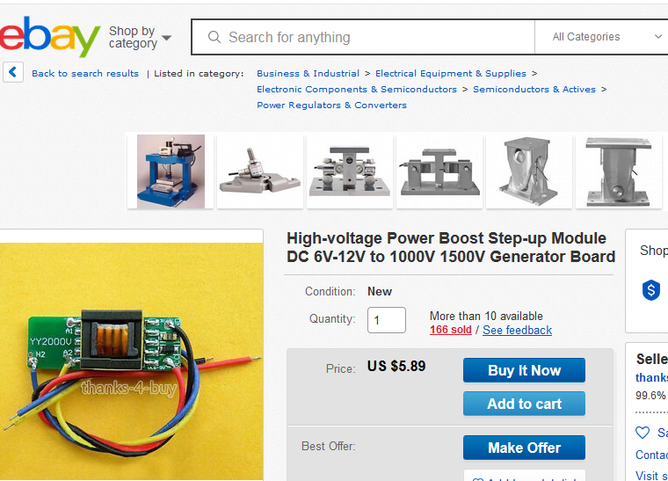

Tony Rodda and I have been working with the Relco lamps and this supply and have found that specific connections must be used in order to keep the lamp lit. Specifically use the terminals A1 and A2 to connect to the lamp( not A1 & H2). There isn’t a need for a series resistor in the high voltage circuit to limit current.

Even though the spec’s indicate that it can be powered from 12V, the lamp will start to dim appreciably after only a short time. I think that the drive MOSFET is over heating. If however you power it from 9V it will give good luminance and continue to operate. Tony has operated the system for over 4 hours on a single common 9V battery.

The emission spectra is here:

